DH
Num | User Requirement | GPT Result | Our System Result
 | The System allows a web ready computer, cell phone or PDA to control a home's temperature, humidity, lights, security, and the state of small appliances. | 1 The system shall provide users with the ability to log in securely from a web-ready computer, cell phone, or PDA. | - The system shall be able to allow a web ready , cell phone or pda to control a homes temperature , humidity , lights , security ,  2. The system shall be able to small state appliances.
 | Users monitor and control home devices and systems. | Missing | 3. The system shall provide users with the ability to monitor and control home devices and systems.
 | The system equipes with various environmental controllers and sensors. | Missing | 4. The system shall be able to equip with various environmental controllers and sensors.
 | The sensor reads and saved value in the home database. | Missing | 5. The system shall provide sensor with the ability to read and saved value in the home database.
 | The user read the temperature at a thermostat position. | 2 The system shall provide users with the ability to monitor the current temperature at each thermostat position. | 6. The system shall provide user with the ability to read the temperature at a thermostat position.
 | The user set the thermostat temperatures to between 60 ° F and 80 ° F, inclusive, at one degree increments. | 3 The system shall provide users with the ability to set the thermostat temperature between 60°F and 80°F, inclusive, at one-degree increments. | 7. The system shall provide user with the ability to set the thermostat temperatures to between 60 f and 80 f , inclusive , at one degree increments.
 | If a thermostat device allows a user to make a manual temperature setting, the setting remains in effect until the end of the planned or default time period, at which time the planned or default setting will be used for the next time period. | 30 If a user manually sets a thermostat temperature, then the system shall maintain the manual setting until the end of the planned or default time period. | 8. The system shall provide user with the ability to to make a manual temperature setting , the setting remains in effect until the end of the planned or default time period , at which time the planned or default setting used for the next time period.
 | The system compatibles with a centralized HVAC (Heating, Ventilation and Air Conditioning). | 24 The system shall be compatible with a centralized HVAC system for temperature and humidity control. | 9. The system shall be able to compatible with a centralized hvac heating , ventilation and air conditioning.
 | The system adheres to the standards, policies and procedures of the American Society of Heating, Refrigerating and Air-Conditioning Engineers [ASHRAE 2010]. | 25 The system shall adhere to the standards, policies, and procedures of ASHRAE 2010. | 10. The system shall be able to adhere to the standards , policies and procedures of the american society of heating , refrigerating and airconditioning engineers ashrae 2010.
 | The user monitor and control a home’s humidity from any location, using a web ready computer, cell phone, or PDA. | Missing | 11. The system shall provide user with the ability to control usingThe system shall provide user with the ability to read the humidity at a humidistat position.
 | The user read the humidity at a humidistat position. | 6 The system shall provide users with the ability to view the current humidity at each humidistat position. | Missing
 | The user sets the humidity level for a humidistat, from 30% to 60%, inclusive a 1% increments. | 7 The system shall provide users with the ability to set the humidity level for a humidistat from 30% to 60%, inclusive, at 1% increments. | 12. The system shall provide user with the ability to set the humidity level for a humidistat , from 30 to 60 , inclusive a 1 increments.
 | The system uses wireless signals to communicate, through the master control unit, with the humidistats. | 23 The system shall use wireless signals to communicate with humidistats through the master control unit. | 13. The system shall be able to use wireless signals to communicate , through the master control unit , with the humidistats.
 | The system consists of contact sensors and a set security alarms. | Missing | 14. The system shall be able to consist of contact sensors and a set security alarms.
 | The system manages up to fifty door and window contact sensors. | Missing | 15. The system shall be able to manage up to fifty door and window contact sensors.
 | The system activates both light and sound alarms one sound alarm and one light alarm subsystem, with multiple lights. | 19 The system shall be able to activate a sound alarm subsystem when a security breach is detected. | 16. The system shall be able to activate both light and sound alarms one sound alarm and one light alarm subsystem , with multiple lights.
 | The system provides information about the state of a power switch (OFF or ON), indicating the whether an appliance connected to the power switch is OFF or ON. | Missing | 17. The system shall be able to provide information about the state of a power switch off or on , indicating the whether an appliance connected to the power switch off or on.
 | The system changes the state of a power switch (OFF to ON, or ON to OFF), in turn changing the state of an appliance connected to the power switch. | 12 The system shall provide users with the ability to monitor the state (ON or OFF) of each appliance connected to a power switch. | 18. The system shall be able to change the state of a power switch off to on , or on to off , in turn changing the state of an appliance connected to the power switch.
 | If a user changes the state of power switch device manually, the device remains in that state until the end of the planned or default time period, at which time the planned or default setting will be used for the next time period. | 32 If a user manually changes the state of a power switch, then the system shall maintain the manual state until the end of the planned or default time period. | Missing
 | The system set various preset home parameters (temperature, humidity, security contacts, and on/off appliance/light status) for certain time periods. | 26 The system shall provide users with the ability to set preset home parameters (temperature, humidity, security contacts, appliance/light status) for certain time periods. | 19. The system shall be able to set various preset home parameters temperature , humidity , security contacts , and onoff appliancelight status for certain time periods.
 | System provides a monthly planner. | 27 The system shall provide users with the ability to schedule parameter changes using a monthly planner. | 20. The system shall be able to provide a monthly planner.
 | The user overrides planned parameter values, through the DH website, or if available, through manual switches on household devices. | 28 The system shall provide users with the ability to override planned parameter values through the DH website. | 21. The system shall provide user with the ability to override planned parameter values , through the dh website , or if available , through manual switches on household devices.
 | The system provides a report on the management and control of the home. | 39 The system shall provide users with the ability to generate a report on the management and control of the home. | 22. The system shall be able to provide a report on the management and control of the home.
 |  | 5 If a user attempts to set a thermostat temperature outside the valid range, then the system shall display an error message and reject the input.
 |  | 8 The system shall validate that any humidity level set by the user is within the range of 30% to 60%, inclusive.
 |  | 9 If a user attempts to set a humidity level outside the valid range, then the system shall display an error message and reject the input.
 |  | 10 The system shall provide users with the ability to monitor and control the state (ON or OFF) of each light in the home.
 |  | 11 The system shall provide users with the ability to turn any light ON or OFF remotely.
 |  | 13 The system shall provide users with the ability to change the state of a power switch from OFF to ON or from ON to OFF.
 |  | 14 The system shall update the state of the connected appliance to match the state of the power switch.
 |  | 15 The system shall provide users with the ability to monitor the status of all door and window contact sensors.
 |  | 17 The system shall provide users with the ability to view the status (open or closed) of each door and window contact sensor.
 |  | 18 The system shall provide users with the ability to arm or disarm the security system remotely.
 |  | 21 The system shall be able to record sensor readings (temperature, humidity, contact sensors) in the home database.
 |  | 22 The system shall be able to retrieve the latest sensor readings from the home database for display to the user.
 |  | 34 The system shall provide users with the ability to view scheduled parameter changes for all devices.
 |  | 35 The system shall provide users with the ability to edit or delete scheduled parameter changes.
 |  | 36 The system shall provide users with the ability to receive confirmation messages after successfully changing device states or settings.
 |  | 37 The system shall provide users with error messages if a device fails to respond to a control command.
 |  | 38 The system shall provide users with the ability to view historical logs of device states and sensor readings.
 |  | 41 The system shall provide users with the ability to receive notifications of security breaches via the web interface.
 |  | 42 The system shall provide users with the ability to receive notifications of security breaches via email or SMS.
 |  | 43 The system shall provide users with the ability to receive notifications when scheduled parameter changes are executed.
 |  | 44 The system shall provide users with the ability to receive notifications if a device is offline or unresponsive.
 |  | 45 The system shall provide users with the ability to view the current status of all connected devices on a dashboard.
 |  | 46 The system shall be able to log all user actions related to device control and parameter changes.
 |  | 47 The system shall be able to log all system-generated events, such as alarms and sensor readings.
 |  | 48 The system shall provide users with the ability to filter and search historical logs by device, date, or event type.
 |  | 49 The system shall provide users with the ability to reset devices to default settings.
 |  | 50 The system shall validate all user inputs for device control commands before execution.
 |  | 51 The system shall provide users with feedback if an input is invalid or out of range.
 |  | 52 The system shall provide users with the ability to view the connectivity status of each device (online/offline).
 |  | 53. The system shall provide users with the ability to add new devices to the system, subject to compatibility.
 |  | 54 The system shall provide users with the ability to remove devices from the system.
 |  | 55. The system shall provide users with the ability to rename devices for easier identification.
 |  | 56 The system shall provide users with the ability to assign devices to specific rooms or zones.
 |  | 57 The system shall provide users with the ability to view devices by room or zone.
 |  | 58 The system shall provide users with the ability to set up user profiles with customizable access permissions.
 |  | 59. The system shall restrict access to device control functions based on user permissions.
 |  | 60 The system shall provide users with the ability to log out securely from any device.
 |  | 61 The system shall automatically log out users after a period of inactivity.
 |  | 62 The system shall encrypt all communications between user devices and the system.
 |  | 63. The system shall back up the home database regularly to prevent data loss.
 |  | 64 The system shall provide users with the ability to restore settings from a previous backup.
 |  | 65 The system shall provide users with the ability to view system status and health information.
 |  | 66 The system shall provide users with the ability to receive maintenance notifications for system updates.
 |  | 67 The system shall provide users with help and support resources accessible from the web interface.
 |  | 68 The system shall provide users with the ability to submit feedback or report issues through the web interface.
 |  | 69 The system shall provide users with the ability to customize notification preferences for different event types.
 |  | 70 The system shall provide users with the ability to view compliance information regarding ASHRAE 2010 standards.
 |  | The system shall update the state of the connected appliance to match the state of the power switch.
 |  | 40 The system shall provide users with the ability to download or print the home management report.
 |  | 29 The system shall provide users with the ability to override planned parameter values using manual switches on household devices, if available.
 |  | 33 At the end of the planned or default time period, the system shall revert the power switch to the planned or default setting for the next time period.
 |  | 20 The system shall be able to activate a light alarm subsystem with multiple lights when a security breach is detected.
 |  | 31 At the end of the planned or default time period, the system shall revert the thermostat to the planned or default setting for the next time period.

Class Diagram(VeriGen):

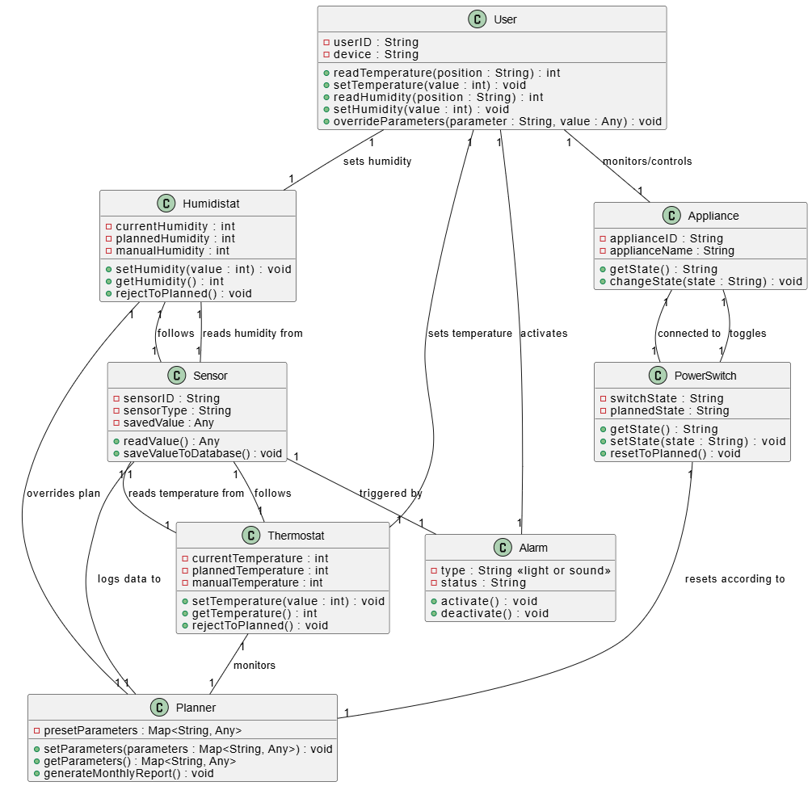
Class Diagram(GPT)
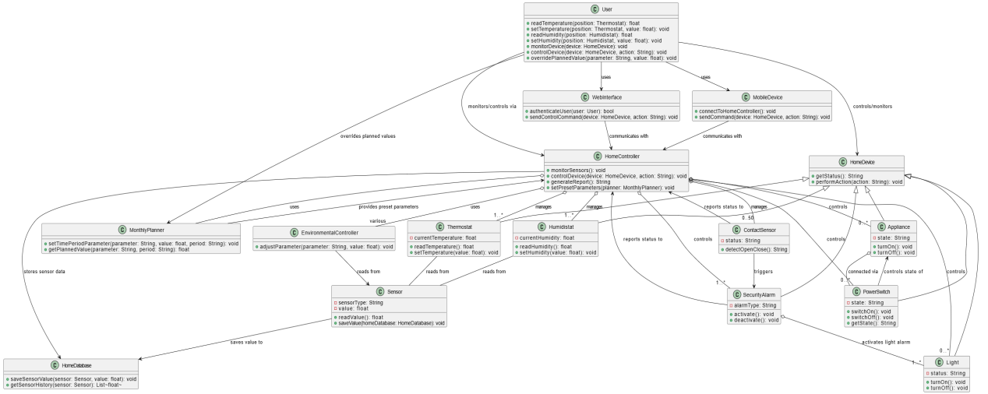

Sequence Diagram (VeriGen)
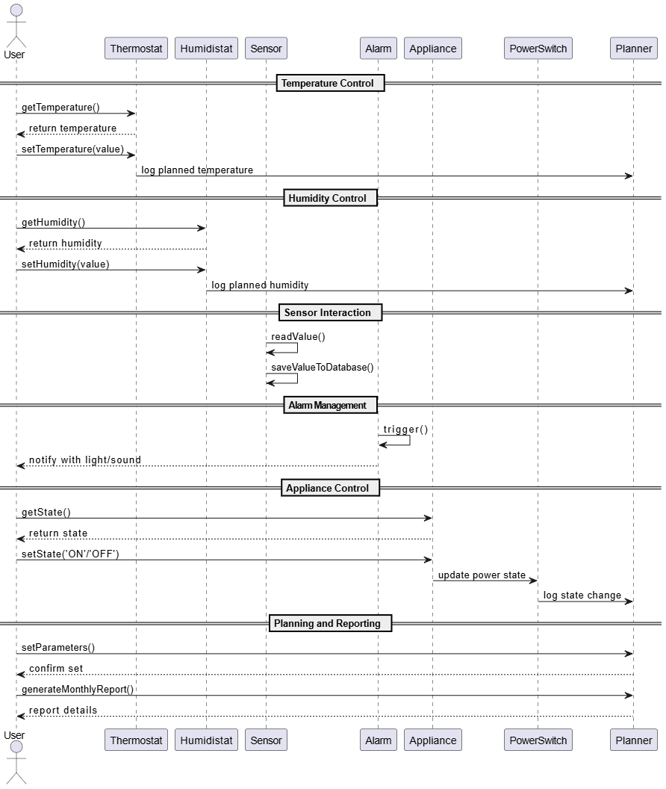

Sequence Diagram (GPT)
